TOURING & TECHNICAL SPECIFICATIONS
Last update October 2025
to disappoint a god.
By Carmen Yih

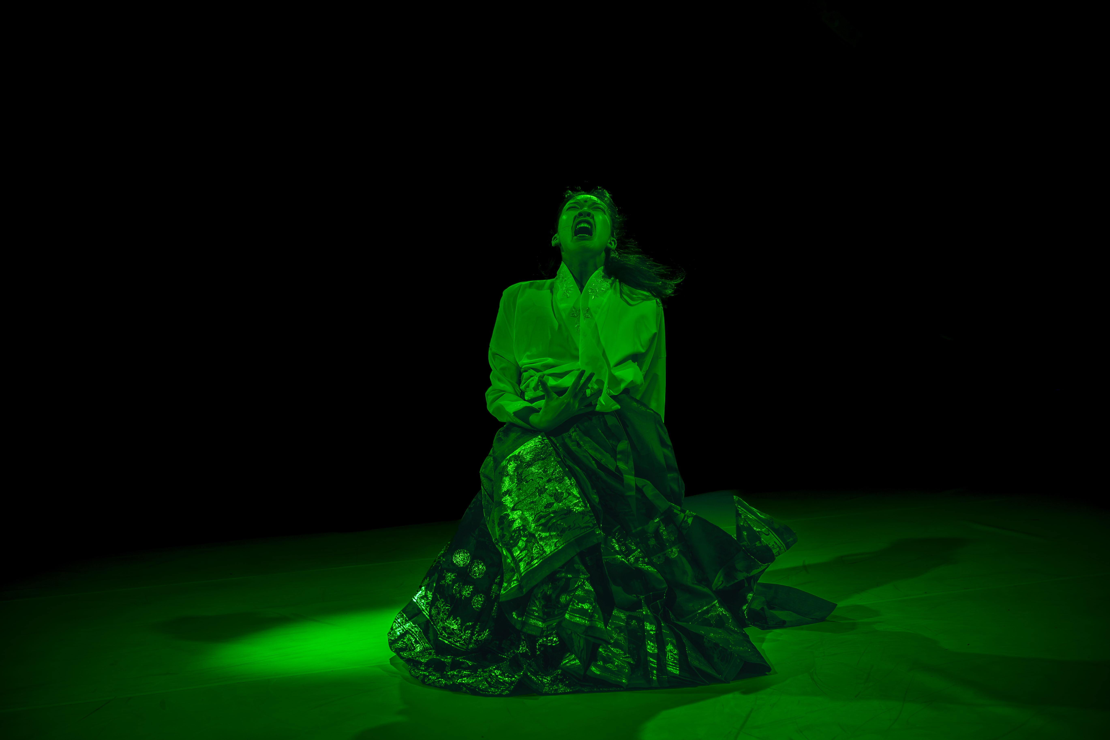
(Image by Gregory Lorenzutti – Dancehouse 2024)

CONTACTS

For all enquiries related to potential presentations, performance agreements, marketing or tour logistics please contact Insite Arts, the Producers.
Stella Webster | Producer | Insite Arts
stella@insitearts.com.au | +61 490 066 299

For all enquiries related to technical production, please contact Lead Creative, Carmen Yih
Carmen Yih | Lead Creative | to disappoint a god
hitahhchi@gmail.com | +61 410 355622

Introduction
This Touring and Technical Specifications document is an integral element of any to disappoint a god presentation.

Should variations be necessary to the technical elements requested within this document, these must first be negotiated and be agreed to in writing with the Producer, Lead Creative and Production Manager, and in advance of the Performance Agreement being executed.

TABLE OF CONTENTS

ABOUT THE PROJECT Synopsis 3
Creative Team
Format

GENERAL PERFORMANCE DETAILS Duration 3
Programming
Capacity
Age Restrictions
Latecomers
Language
PRESENTATION AGREEMENT Introduction 4
Touring Company
Travel
Interpreters
Show Freight

VENUE REQUIREMENTS Performance Space | Size & Layout 5
Back-of-House Requirements

GENERIC PRODUCTION SCHEDULE

TECHNICAL REQUIREMENTS Set 6
Lighting
Sound

PLANS Stage Plan
LX Plan
AV Plan
SX Plan

STAFFING REQUIREMENTS Technical Staffing | Presenter / Venue 7
FOH Staffing

ABOUT THE PROJECT

Synopsis
to disappoint a god. is a hybrid Asian-futurist dance-theatre work starring Nuwa (女媧) – a Chinese mythological creation deity. Nuwa embodies the dichotomy of our existence; our grief, agony, guilt and anger encased in the gentle, desperate fight to hold onto hope.
to disappoint a god. uses Nuwa as a vessel to call for personal reflection and accountability amid the global breakdown of climate, culture and communication.
Drawing from a smorgasbord of training across Chinese folk dance, Contemporary dance-theatre, Krump, and W_acking, to disappoint a god. physically and conceptually contorts the archetypal ‘asian diasporic femme body’; blending human and non-human, comfort and discomfort, strength and vulnerability.

Creative Team

Choreographer / Performer: Carmen Yih
LX Design: Elekis Poblete & Giovanna Yate Gonzalez
Sound Design: Amelia Jean O’Leary, Damon Shearer
Producer: Insite Arts

Format
TDAG is a 40min live dance-theatre work designed for the blackbox theatre (able to adapt to unconventional indoor performance venues upon negotiation).

The work is performed live by a solo dancer (Yih), with recorded sound, and minimal lighting.

to disappoint a god. is a small-scale work suitable for end-on theatres and can be scaled to suit an audience capacity of between 20-200 persons.

The work can be adapted for unconventional theatre spaces, outdoor spaces and music venues upon discussion with the artist.

GENERAL PERFORMANCE DETAILS

Duration Performance runs for approximately 40 minutes, with no interval.

Programming Show can be performed up to 2 times per day with matinee and evening shows possible. A turnaround of at least 2 hours between performances is required.

Capacity Audience Numbers are defined by the scope of the venue.

Age Restriction Performance is appropriate for people of all ages, but recommended for ages 15+

Latecomers to disappoint a god. has no latecomer requirements, and all latecomers are welcome. Wherever possible, we request latecomers are seated in a position that lessens the impact of their arrival on the performance.

Language to disappoint a god. is primarily a dance work, however it does include English and Cantonese spoken text. If surtitles are required, please discuss with the company during planning for the presentation.

PRESENTATION AGREEMENT

Touring Company
The Production will travel with between 1 and 3 people, depending on the nature of the presentation and the bump-in and technical team available.

Carmen Yih Choreographer & Performer
Elekis Poblete Lighting designer & operator
Stella Webster Producer / Tour Manager

The Production may engage local operator at the expense of the presenter instead of the Aus based operator. This would need to be determined in advance of confirming the season and additional rehearsal/bump in time will be required for the operator to learn the show.

Travel
Travel to the location where the Presentation is to take place, will be coordinated by the Producer in consultation with the Presenter and the Touring Company. The Presenter will be responsible for all associated travel costs. The Producers will support funding applications for touring support where applicable.

The Presenter shall provide private room accommodation in minimum four-star accommodation for each member of the Touring Company. This is an Australian Union Requirement. Accommodation must include free unlimited Wifi.

For stays of one week or longer, accommodation with cooking and laundering facilities is ideal and appreciated.

The Presenter is responsible for all airport to accommodation transfers for the Touring Company in the local city of the presentation. Ideally the accommodation provided should be walking distance (no more than 15 minutes) from the venue (or easily accessible via public transport, with no longer than 15 minutes commute between accommodation and venue). Should this not be possible, the Presenter is to provide adequate ground transport (such as a venue pool car, hire car or taxis) for use by the Touring Company.

Interpreters
In locations where English is not the primary language, the Presenter must make at least one interpreter
available to the Touring Company in the venue at all working times to communicate with the theatre staff and crew. This includes all work calls, rehearsals and all performances.

The interpreter/s must be completely bilingual (English and local language) and familiar with technical
theatre terminology. Under NO circumstances may the interpreters be members of the working crew.

Show Freight
The Production’s touring components inclusive of instruments, props, costumes will be brought to the season via show freight.

The show freight must arrive at the venue, in advance of and be accessible for the beginning of the first day of bump in. It is the Presenters responsibility to coordinate and pay for the costs associated with the collection and movement of the show freight in consultation with the Producers.

VENUE REQUIREMENTS

Performance Space | Venue Size and Layout
to disappoint a god. can be presented in a wide variety of venues that have sufficient sound, lighting, stage and auditorium features.
to disappoint a god. can be performed in a black-box or proscenium arch venue, a warehouse or any number of multi-purpose spaces. The venue must be able to be blacked out fully, at all times.

A flat (unraked), preferably-sprung floor is required with a minimum 9m in width and 9m in depth of clear stage space.

It is expected that the Venue’s Technical Specifications, as supplied to the Company, are up-to-date and list all elements available for use by the Company. Please inform the Production Manager as soon as possible if any elements are unavailable or not as described.

Back-of-House Requirements
Presenter will provide the Company with:
• Dressing room areas for the performer
• Access to a green room for all members of the company.
• Laundry Facilities for laundering and maintaining costumes. Facilities should include washing & drying facilities, steamer, iron and ironing board.

PRODUCTION SCHEDULE
A detailed production schedule will be created in consultation with the Presenter and Venue Production team.

Below is a generic schedule which describes a best-case scenario and is dependent on the Venue, the Production team made available and with all requested equipment supplied in good working order from the commencement of the bump-in.

It is expected that the LX & AV will be pre-rigged according to the provided plans prior to the company commencing work in the venue.

 | ACTIVITY | PERSONELL | LOCATION
Day 1 | Bump in & production install  Set install & LX plot/focus, sound checks | Venue Production team &  Touring Company | Venue
Day 2 | Dress Rehearsal  Performance 1 - evening | Touring Company | Venue
Day 3 | Performance 2  Performance 3 | Touring Company | Venue
Day 4 | Performance 4  Performance 5  Bump out | Touring Company  Venue Production team | Venue

TECHNICAL REQUIREMENTS – SUPPLIED BY THE PRESENTER

The following is a list of technical equipment to be provided by the presenter.
The touring company will be responsible for providing all costumes, props & scenic elements not listed below. These elements will be included in the show freight.
Any and all amendments to the equipment to be supplied, must be discussed with the Lead Creative, Production Manager and Producers prior to signing of the final performance agreement.

Set
- White dance flooring (Tarkett or similar) that covers the full surface area of the stage
- 2 x hazers

Lighting
Lighting Design is venue dependant, with a plan supplied in advance.
In house LX fixtures will be utilised and may require repositioning.
Additional lighting fixtures may be required (external hires).
1x show computer (Mac) with full QLab licence to be supplied by the venue.

Audio Visual
Sound-system
1 X Wireless mic pack, pack strap, receiver & lapel mic (Sennheiser, Shure etc professional quality range preferred)
No projectors required

PLANS

<Stage Plans> To be supplied.

<LX Plans> To be supplied.

< SX Plans > To be supplied.

VENUE STAFFING REQUIREMENTS
The Presenter is required to supply the following Production/Technical Staff:

ROLE | WHEN | TASKS
Venue Manager | INSTALL  SHOW  BUMP OUT | INSTALL - Oversee installation of production into venue.  SHOW - Oversee the presentation of the show.  BUMP OUT -Oversee the venue bump out.
SX Technician | INSTALL  BUMP OUT | INSTALL  - Lead the pre-rig and installation of the SX equipment as per the SX Design.  - Program SX into the desk,  SHOW  - Mic up x1 performer for each performance, run mic checks  BUMP OUT  -Oversee the bump out of SX in the venue as needed.
LX Technician  LX & SX Operator | INSTALL  SHOW  BUMP OUT | INSTALL  - Lead the pre-rig and installation of the LX equipment as per the LX Design / guided by Lighting Designer.  - Program LX into the desk, assist with focus & plot.  - Connect LX to our QLAB via OSC, OR operate LX depending on venue requirements  SHOW  - Preshow LX checks as needed  BUMP OUT  -Oversee the bump out of LX in the venue as needed.
Crew | INSTALL  BUMP OUT | INSTALL  - Support the installation of touring set components.  BUMP OUT  -Support the venue bump out and assist with removal of all set components.

Front of House Staffing
The Presenter is required to supply appropriate numbers of FOH staff as required for the audience size, layout of the venue and ticketing system.

Please note: all final staffing arrangements should be confirmed with the Producer prior to the arrival of the Touring Company and after consultation of the venue-specific Production Schedule.

