Access Information
40-LOVE by Dr. Jonathan Homsey
Dancehouse is on Wurundjeri Country. We offer our respects to the Wurundjeri woi-wurrung people — and to all Aboriginal and Torres Strait Island people — who continue to dance on Country, and have done, for thousands of generations. Always was and always will be Aboriginal land.

Where:
Dancehouse (Upstairs Studio)
150 Princes St
Carlton North

When
7pm, Wednesday 7th - Saturday 10th of October
Approximately 45 minutes with no interval.

Contact Dancehouse
By phone: 9347 2860. Monday – Friday, 9:30am - 5:30pm.
By email: info@dancehouse.com.au
Please note:
Access to the Upstairs Studio, where the performance will take place, is via staircase only (30 steps in total). Unfortunately, there is no lift access to this space.
A digital on-demand viewing of 40-LOVE will be available from the 16th to 18th of October.
If you have specific access requirements you would like us to know about, or would like to discuss your visit in advance, we encourage you to contact Dancehouse ahead of time.

TABLE OF CONTENTS
Getting to Dancehouse 3
Closest tram stop (not street level accessible) 3
Closest street level tram stop 3
Parking 4
Car drop off 4
Before the show 4
Venue access 4
Foyer & bar 4
Bathrooms 5
Late arrivals 5
Pre-show familiarisation 5
Sighted guidance choreography demonstration 5
During the show 6
The performance space 6
Physical access 7
Seating arrangements 8
Late arrivals 8
Show content 8
Sensory information 9
Audio Description 9
Access for d/Deaf and hard of hearing patrons 10

Getting to Dancehouse
Dancehouse is located at 150 Princes St, Carlton North and is close to tram routes 1, 6 and 96. Street parking in the surrounding area is limited, so audiences are encouraged to plan ahead.

Closest tram stop (not street level accessible)
Stop 144 Princes/Lygon St on Trams 1 and 6, is the closest stop to Dancehouse (170m away). Both routes travel north from Federation Square/Swanston St, turn right into Elgin St and then left along Lygon St.
Stop 144 is in the centre of Lygon St, on the north side of Princes St. You will need to cross one lane of traffic to your right as you exit (reverse if you are travelling south) and then follow Princes St for approximately 170m to find Dancehouse on your left.
You will cross over Drummond St on your way which is closed to traffic (no intersection to cross). If you reach the traffic lights at Rathdowne St you have gone too far.

Closest street level tram stop
Stop 15 Alexandra Pde/Nicholson St on Tram 96 is the closest level access stop (550m to Dancehouse). YarraTrams aims to run every service on Route 96 with a low-floor tram.
The 96 runs from Spencer St/Bourke St and turns left to travel north up Nicholson St. Stop 15 Alexandra Pde/Nicholson St is around 100m north of Alexandra Parade. You will need to cross one lane of traffic over Nicholson St to your left and walk back down Nicholson St towards the intersection before turning right into Alexandra Pde (reverse if travelling south).
You will cross over 3 intersections on this route. The first, Station St has no traffic lights but there is a sign to give pedestrians right of way when crossing the road. Following this are Canning St and Rathdowne St which are both major intersections with traffic lights. Dancehouse is around 80m past the Rathdowne St intersection on your right.

Parking
There is limited paid and/or timed on-street parking on Rathdowne St, Drummond St and Princes St, although spaces tend to fill up quickly.
The closest disabled parking bays are around the corner from Carlton Library at 64 Newry St. There are 2 bays only. Dancehouse is around a 350m walk from Newry St, down Rathdowne St and turning right onto Princes St.

Car drop off
Please note there is no space for cars to pull over directly out the front of Dancehouse, however there is a laneway along the left side of the building where a car could temporarily pull in to drop passengers off. An easier option for car drop off could be around the corner in Rathdowne St.

Before the show

Venue access
Access to the foyer of Dancehouse is via an external ramp with handrails either side. Access to the Upstairs Studio, where the performance will take place, is via staircase only (30 steps in total). Unfortunately, there is no lift access to this space.
Foyer and bar
The foyer and bar will be open from 6:30pm. The foyer has some limited seating around its perimeter and can become quite busy and loud. The front door of Dancehouse is usually left ajar before performances and some people prefer to wait outside.

Bathrooms
Wheelchair accessible and gender neutral bathrooms are located on the ground floor to the right of the foyer.

Late arrivals
No entry after 7:10pm. If you are less than 10 minutes late, a Dancehouse staff member will guide you to a seat.

Pre-show familiarisation
Audience members who would benefit from being in the space early are welcome from 6:45pm on Wednesday or Thursday shows. Unfortunately, there is only five minutes of pre-show Friday and Saturday nights due to another performance taking place in the theatre below.
The creative team are very happy to demonstrate anything that might make the show more accessible for you. This might include things like hearing the sound at its loudest or seeing lighting states. Please let a Dancehouse staff member know if you would like to be introduced to a member of the creative team before the show.

Sighted guidance choreography demonstration
Audience members who would benefit from being in the space early are welcome from 6:45pm on Wednesday or Thursday shows. Blind and low vision ticket holders for Wednesday or Thursday shows are invited to enter the space early for a 6:45pm pre-show choreographic demonstration. This will be facilitated by the performers who will offer sighted guidance and description of some of the dance moves. Please contact Dancehouse in advance if you would like to take part in this.

During the show

The performance space
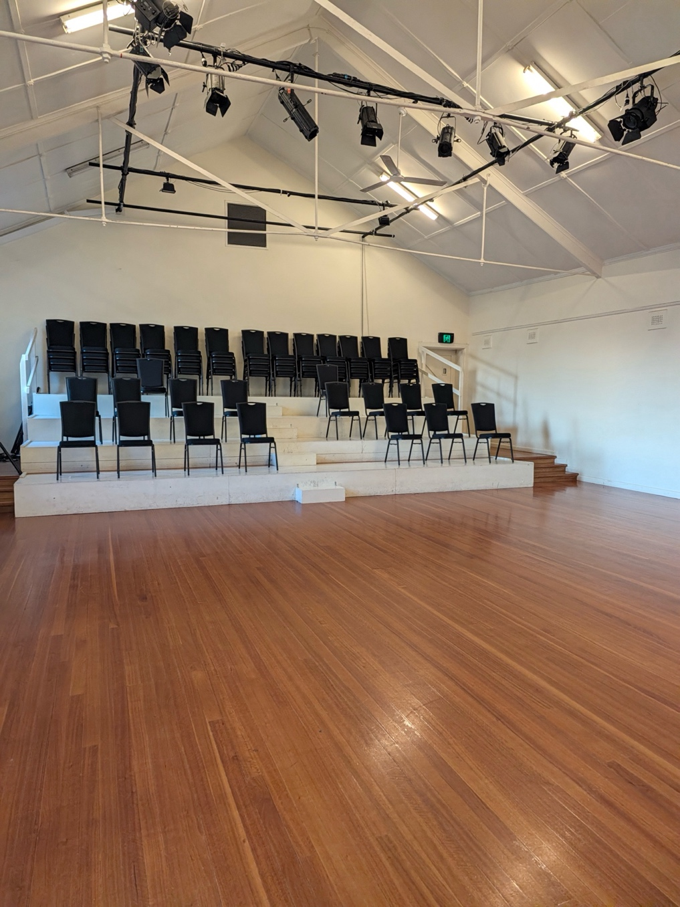
A photo of the Upstairs Studio taken from the entrance. The room has a polished wooden floor, white walls and a high white ceiling with stage lights overhead. At the back of the space is a low tiered white platform with 4 rows of black chairs.
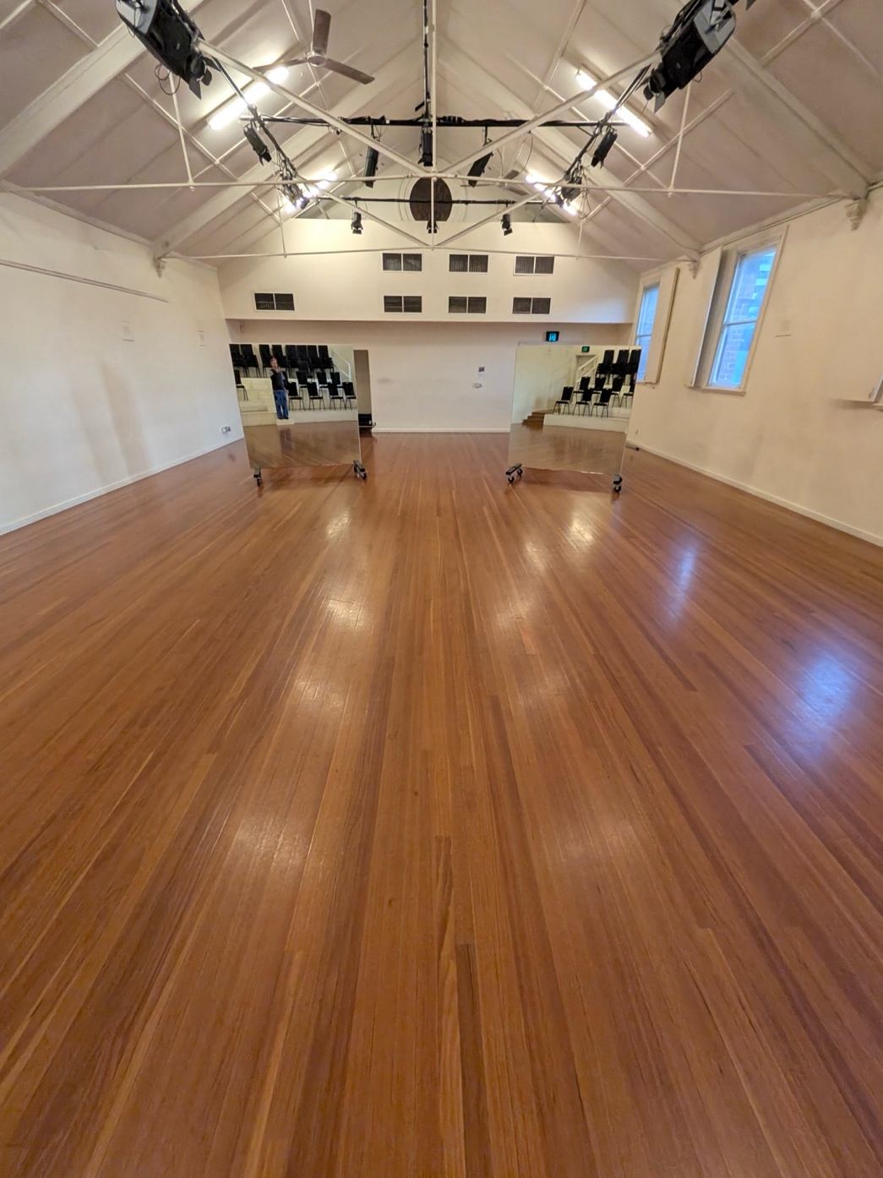
A photo of the Upstairs Studio taken from the seating bank, facing back towards the performance space with the entrance at the far end of the room. The polished wooden floors reflect stage light from above. In this photo the entrance is obscured by one of two large square mirrors facing the audience which stand freely on wheels. Parts of the seating bank can be seen in their reflection.

Physical access
- The Upstairs Studio at Dancehouse is not wheelchair accessible. Access is available only via two flights of stairs (30 steps in total).
- The Upstairs Studio at Dancehouse is a very large space (9.5m x 14m) with polished wooden floors and high ceilings
- More information about the Upstairs Studio is available HERE.

Seating arrangements
- Seating can be arranged to accommodate access needs where possible
- Tickets are not allocated to seats. Please let Dancehouse staff know if you need to reserve a particular spot for better accessibility
- Ticket holders need to cross the length of the room to reach the audience seating

Late arrivals
No entry after 7:10pm. If you are less than 10 minutes late, a Dancehouse staff member will guide you to a seat at 7:10pm.

Show content
40-LOVE is a contemporary dance piece with heightened theatrical elements. Two dancers perform with a range of movement qualities including high energy “Krump”, and dynamic “Vogue” styles. Their dance moves correspond to repeated sound effects which are part of an amplified soundtrack.

Sensory information
40-LOVE involves:
- Pre-recorded amplified sound at high volume in an echoey space
- Voice over, dynamic music and some potentially jarring sound effects
- Changing lighting states over the performance area
- Projection of text onto the floor
- Mirrors at the back of the performance space which face the audience
- Low level overhead light in the audience throughout
- Occasional moments where performers come close to the seating bank
Audience members with sensory sensitivities may wish to contact the venue in advance for further detail.

Audio Description
Creatively embedded audio description is a key feature of 40-LOVE.
Some pre-recorded audio description is integrated into the sound design and parts of choreography are linked to a sound key where certain dance moves correspond with specific sound samples. A full written description of movement, characters and links to the sound key will be emailed to all ticket holders along with pre-show notes ahead of the show.
Blind and low vision ticket holders for Thursday or Wednesday shows are invited to enter the space early for a 6:45pm pre-show choreographic demonstration. This will be facilitated by the performers who will offer sighted guidance and description of some of the dance moves. Please contact Dancehouse in advance if you would like to take part in this.

Access for d/Deaf and hard of hearing patrons
All spoken word will be displayed as captions via a monitor at the front of the audience. Unfortunately, we are not able to provide Auslan interpretation for 40-LOVE at this stage.
40-LOVE is presented by Melbourne Fringe and Dancehouse. This project has been Fringe Funded, as part of Pulse, and has been made more accessible with support from Access Fringe. Dancehouse is committed to making performances as accessible and welcoming as possible for all audiences.

