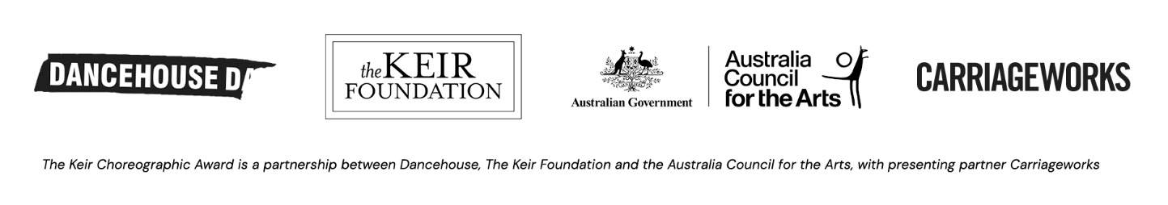

2022 KEIR CHOREOGRAPHIC AWARD ENTRY FORM

IMPORTANT REMINDER
Please Ensure that you and your prospective team agree to the Terms and Conditions set out in the application guidelines before you apply. No negotiations of these terms are possible. The Keir Choreographic Award offers a funded opportunity to generate and present a short work in a high-profile context. Please carefully consider your relationship to the competitive nature of the Keir Choreographic Award before you submit your application.

CLEARLY ARTICULATE IN 100 WORDS A SUMMARY OF YOUR CHOREOGRAPHIC IDEA

PLEASE PROVIDE A 250 WORD BIOGRAPHY

YOUR 2022 KEIR CHOREOGRAPHIC AWARD COMMISSIONING BUDGET
Please fill out the budget table below detailing how you propose to spend the $12,000 Commissioning Budget. Please do not include any in kind or personal cash contributions. Your budget must not exceed $12,000.

EXAMPLE BUDGET:

Expenses | Amount | Description/Breakdown
Fees and Wages | $9,500 | Lead Artist Rehearsal Wage - $4000 , Other Performers Rehearsal Wages $4000, Sound/Costume/Set Designer Fees - $1000, Consultants - $500
Superannuation | $950 | Calculated as 10% of Fees and Wages
Production Costs | $1,550 | Costumes - $500, Materials - $500, Additional Freight $200 Contingency $350.
TOTAL | $12,000

YOUR BUDGET:

Expenses | Amount | Description/Breakdown
Fees and Wages
Superannuation
Production Costs
TOTAL

YOUR 2022 KEIR CHOREOGRAPHIC AWARD TOURING PARTY

Please list out the names, contact details - phone numbers, email addresses and home cities - of your Touring Party. Only those performing live in the work and the lead artist/ choreographer are permitted to tour with the work to a maximum of five people per project. Quintets are only possible if they feature the lead artist/ choreographer as a performer.

The KCA strongly encourages projects with smaller touring teams than the maximum and will select works for presentation with a combined maximum touring party across the whole KCA of 28 people.

There may be other people - sound designers, costume designers, dramaturgs etc. - in your artist team that will no travel with the work. These can be confirmed at a later stage.

It is your responsibility to fill this form out correctly. If successful, you will not be able to increase your touring party and you may not be permitted to change your artistic team. Do not include the names of any artists who are not confirmed. Unfortunately, the commissioners are not able to support collaborators who reside outside of Australia.

Name | Phone | Email | Role | Home City they will travel from

BEFORE YOU SUBMIT PLEASE CHECK:

You have carefully read and understood the Full Application Guidelines and Regulations and that you are eligible to apply.

You have uploaded a video of no longer than 5 minutes and no more than 2GB in size and ensure the WeTransfer link you provide above is working. It is a condition of entry that you send through one link and one mp4 file no more than 2GB in size. No other files or links to other online video platforms are allowed (Vimeo, YouTube, etc.). Please check the link and that you are happy with the quality of the video.

That you have not included a Lighting Designer as an Additional Collaborator.

This application is only three pages in length and please rename as follows:
YOUR NAME – 2022 KCA APPLICATION.

CONTACT
If you experience any difficulties in submitting application, please contact:

ASHLEY DYER DANCEHOUSE PROGRAM MANAGER
03 9347 2860 / kca@dancehouse.com.au

TO SUBMIT
Upload this application to the online form: https://airtable.com/shrWCkOQvjGFrx8MR

All entries must be received by 5pm MONDAY 13 DECEMBER 2021.
Late applications will not be considered. All applicants will be notified on 21 JANUARY 2021.

